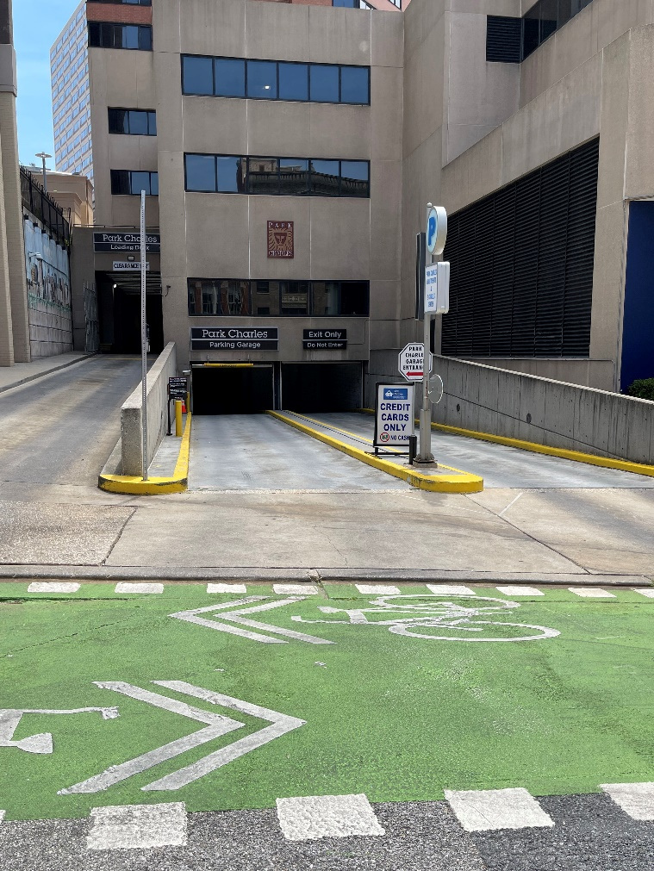
While the address of our office is 218 N. Charles Street, the address of our Parking garage, and the address you should plug into your GPS, is 211 N. Liberty Street, Baltimore, MD. 21201. (If you are walking, you may use 2 Charles Plaza as the address to find our space.)

- The garage is about a ½ block from Saratoga Street, and the entrance will be on your left (see picture). It is a bit tricky as there are entrances to several buildings here, plus a bike lane which has a bunch of white poles sprinkled all around. You will want to drive slowly and look for a break in where the white poles are so that you can turn left into the garage. Also check for bikers and pedestrians! Drive in the entrance and take a ticket at the bottom of the hill.
- Once you enter and pull a ticket, look for spots reserved for Gallagher & Brightview Employees on the A, B & C levels or spots labeled for Visitors.
- After you park, you will want to find the commercial elevator on level B. (Note: This is an interesting garage that features a residential and a commercial elevator.) Use the intercom system and follow directions to the second floor. You will check in with the attendant on the second floor and then proceed to the 4th floor where we are located. (If you park on levels C, D or E, you will need to walk up the garage stairs to level B for the commercial elevator.)
- Bring your parking ticket with you, and we will validate it for you.
- Feel free to call our main line at 410-727-7702 if you have questions or need any assistance the day of.

